General Mills
Convenience & Foodservice
1 General Mills Boulevard
Minneapolis, MN 55426

February 13, 2017

Dear Valued Customer,

General Mills Convenience & Foodservice is announcing a formulation adjustment to select products in our Betty Crocker Fruit Snacks Line. Beginning in late April, 2017 the products listed below will be produced with new ingredient statements and nutritional labels reflecting these changes.

To continue delivering the great taste and quality you expect from Betty Crocker Fruit Snacks, we have improved the formula for increased product resiliency.

Please see the following pages for an examples of new product labeling.

Impacted SKUs:

Product Description | General Mills Product Code | Case UPC/GTIN | Sysco Product Code | Change
Betty Crocker Fruit Gushers Strawberry, 96 ct | 11503000 | 1001600115030 | 8964850 | Acerola removed. %DV of Vitamin C decreased from 25% to 10%
Betty Crocker Fruit by the Foot, 96 ct (Strawberry & Fruit Punch) | 11700000 | 10016000117003 | 6053920 | Acerola Removed. %DV of Vitamin C decreased from 25% to 10%.  No longer reduced sugar
Betty Crocker Fruit by The Foot Berry Tie-Dye, 96 ct | 12106000 | 10016000121062 | 6665517 | Acerola Removed. %DV of Vitamin C decreased from 25% to 10%.  No longer reduced sugar

There are no changes to price, case/ pack size or UPC.

Thank you for your support and cooperation. If you have any questions, please contact your local General Mills representative.

Sincerely,

General Mills Convenience & Foodservice

Betty Crocker Gushers Strawberry
Base Product Code: 11503000
UPC: 1001600011503

Previous Label:

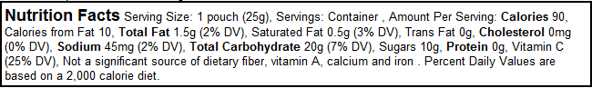

NEW Label:

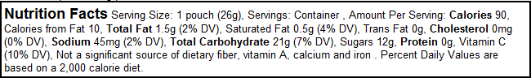

Betty Crocker Fruit by the Foot Variety Pack
Base Product Code: 11700000
UPC: 1001600011700

Previous Label:

Strawberry:

Color by the Foot:

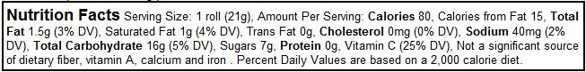

NEW Label:

Strawberry:

Color by the Foot:

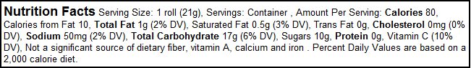

Betty Crocker Fruit by the Foot Berry Tie Dye
Base Product Code: 12106000
UPC: 1001600012106
Previous Label:

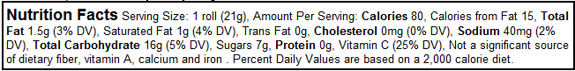

NEW Label:

